**Title**

Relevant, but not Responsible? Reconceptualising Urban Policymakers and the Governance of Urban Climate Action

**Target journal**

GEC? (Im aware this is *wildly* optimistic..)

**Abstract**

Achieving the aspirations of the Paris Agreement and the targets of the Sustainable Development Goals will depend significantly on the actions taken in urban areas, where more than two-thirds of the global population will live in 2050. Drawing on evidence from four continents, this article presents a framework that situates urban policymakers at the centre of a polycentric landscape of urban climate governance. Far from the caricature of merely providing basic services and implementing higher government directives, urban policymakers are seen as critical mobilizers and enablers with a unique role helping to establish the necessary conditions for urban climate mitigation, but a limited role leading action. Understood in this way, a gap exists between urban governments’ expansive ‘relevance’ to the diverse processes that contribute to urban areas’ carbon footprints and the more limited ‘responsibility’ they might reasonably be attributed for addressing these emissions. This perspective raises important questions around how urban governments can achieve the ambitious GHG reduction targets they have increasingly been setting.

**Keywords**

Urban climate change mitigation, cities, climate change, climate change mitigation, non-financial barriers, climate governance

**Authors**

Sudmant, A; Gouldson, A;

1. **Introduction**

Rapid urban expansion presents a critical challenge in the fight against climate change: building the infrastructure alone for an urban population of 6 billion in 2050 would generate emissions equal to four times the amount released from building the existing stock of developed world urban infrastructure, or more than one-quarter of the global 1.5 degree GHG budget under the most optimistic scenario (Peters 2018; ref).

Existing alongside this challenge, however, is an opportunity for transformative social, economic and environmental change to be realised through the way urban areas are developed (Wigginton et al 2016; Bai Shi, & Liu 2014; McPhearson et al 2016). Specific to the challenge of developing low carbon climate resilient cities, a growing body of research reveals the complementarity between actions to address climate change and a wide range of urban issues.

Multi-modal transport networks are not only less energy and emission-intensive, but can improve safety, promote economically efficient urban development, increase social inclusivity, reduce congestion and contribute to clearer air (Litman 2009; Goodwin, 2003; Rode & Burdett 2011). Low carbon buildings have a smaller GHG footprint during their construction and lifespan, but can also reduce fuel poverty and fuel bills, improve public health, and can increase employment during their construction (Ürge-Vorsatz et al 2014). And improved waste management reduces methane emissions, but can also help to address sources of air, water, and soil pollution, improve the lives of the most vulnerable urban populations, and turn a major source of expenditure for local governments into a source of revenue (Parapagoulou et al 2015; Colenbrander et al 2017). Recent research, drawing together evidence from more than 700 pieces of academic literature, finds that the value of co-benefits from urban climate action is frequently substantially larger than the cost of these investments or the value of the energy savings they generate, suggesting that the social and environmental case for urban climate action (even without considering the value of reduced GHG emissions) is often significantly larger than the financial case for action (Gouldson et al 2018).

Coupled with growing evidence for private economic returns from low carbon investment in cities (Sudmant et al 2016; Gouldson et al 2015), and growing awareness that climate change will cause substantial damage to urban areas and the global economy in coming decades (Hoegh-Guldberg et al 2018) the case for low carbon action has never been stronger. Levels of action, however, continue to be far below what is required to prevent dangerous climate change (*). Indeed, even where financial and technical capacities exist, opportunities for low carbon action continue to go unrealised in both developed and developing contexts (Sudmant 2017; Colenbrander 2016; Burch 2010)

Drawing on research from four developing country cities, this article makes the case that embracing an enabling perspective that draws on the many and varied roles of urban governments and the actions they can take to establish the enabling conditions for low carbon actions and address non-financial barriers to action, may empower urban policymakers to have the largest impact. While urban governments have historically been seen as having only a limited set of responsibilities and powers, primarily focused on urban services such as garbage collection, utilities and emergency services (Burstrom and Korhonen, 2001; Betsill 2001), their stature and importance in global efforts to prevent dangerous climate change have increased substantially in recent years.

Through their position between local actors and national and international governments, urban governments are coming to be seen as brokers for agreements and conduits for dialogue and knowledge sharing (Fünfgeld 2015). In their influence over key actions in urban areas, including infrastructure and urban design, urban policymakers are playing a critical role affecting current and shaping future energy and emission trajectories (Gouldson et al 2014; Floater et al 2014; Gouldson et al 2015b). And in the vacuum created as some national governments turn away from climate change, urban areas have become a focal point for climate action in a number of countries (). In 2014 urban areas were recognised among four pillars of action at the UNFCCC, and in recent years more than 9000 cities, representing more than 10% of the global population, have declared emissions reduction targets (Day et al 2018).

At the same time, this article seeks to raise a note of caution around the expectations that are being raised as urban governments set increasingly ambitious targets for reducing emissions. As climate action orients from nations to local actors, and from producers to ‘consumers’ of emissions, it is increasing important to differentiate between actors that have relevance to addressing a specific source of emissions – defined as having some agency to affect the generation of some emissions-, and actors who carry responsibility for addressing a specific source of emissions – defined as carrying some moral responsibility for emissions. In the case of urban governments, it is argued that policymakers have expansive relevance to urban emission through the many and varied ways they can engage with a polycentric urban climate governance landscape. At the same time, urban governments responsibility to address emissions, due to the fact that other actors are situated closer to the points of production of those emissions and to the consumption of the goods and services produced, may be significantly smaller. The implications for urban governments’ increasing ambitious climate actions targets are explored in the discussion section.

In the following, the evolving role of urban governments in the governance of urban climate action in urban areas of the Global South is explored. Section 2 outlines the methodology used by each of the four studies, section 3 provides an overview of each case studty, Section 4 discusses how an enabling approach could lead to higher levels in investment in low carbon options, and Section 5 provides conclusions.

1. **Methodology**

This study draws on results from three previously published city level case studies (Colenbrander 2018; Sudmant et al 2017; Colenbrander et al 2017; Colenbrander 2016) and one city-level report developed using the same methodology whose results are in part found in Qi et al (2017*). These studies assess the city-wide economic case for low carbon measures to affect Scope 1 and 2 emissions. In other words, case studies consider territorial emissions but not emission embedded in goods and services and the consequences of their trade.

First, baseline data were collected for each sector level key unit of analysis (see Figure 1), and for urban economy. Key data for the urban economy include population, GDP, and local climate indicators such as heating degree days (HDD) and cooling degree days (CDD). Data on the wider region include the emissions intensity of the electricity grid. These data are collected for the recent past (up to 10 years) and projected into the future based on previous trends and with consideration for planned investments and changes in government policies.

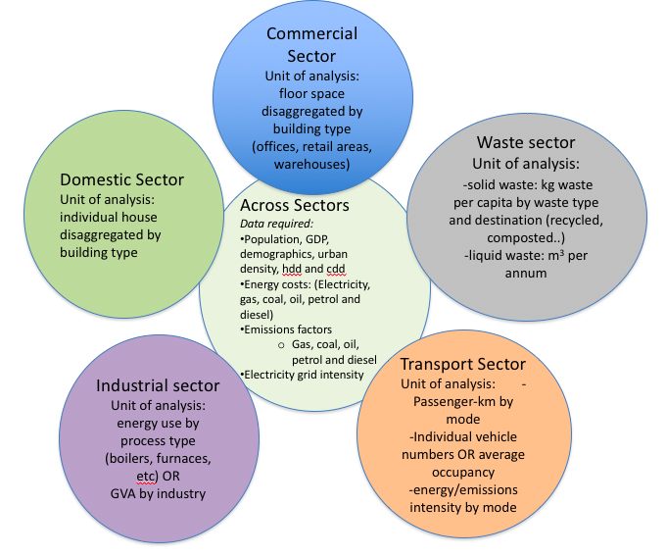

Figure 1: Key baseline data

Second, through literature reviews, interviews and stakeholder dialogues, long-lists of measures are drawn-up for each sector, and for measures that affect multiple sectors (Table 1). Data for each of these measures, including capital costs, energy savings, lifetime, and running cost, are gathered, and a preliminary economic case for the implementation of a single example of a measure is developed. For example, the investment case for a single electric vehicle in the place of a conventional vehicle, is estimated. These results are brought to stakeholders, including experts in the field, in order to evaluate key assumptions.

|  |  |  |  |  |
| --- | --- | --- | --- | --- |
| **Cross-sectoral**  *-changes to the electricity grid (renewable generation, lower carbon generation, investments to prevent electricity losses)*  *-changes to the transport network outside of the urban area*  *-economic factors: energy prices, population change, demographic change, interest rates* | | | | |
| **Domestic**  -Insulation *(cavity, loft and floor)*  -Heating *(boilers, heat pumps, controls, geothermal)*  -Demand reduction *(minor heating, lighting and appliances shifts)*  -Appliances *(refrigeration, cookers, TVs, washing machines)*  -Lighting *(low energy)*  -Small scale renewables (solar and wind) | **Commercial**  -Cooling in retail buildings  -Insulation *(fabric improvements, cavity, loft and floor)*  -Heating *(boilers, heat pumps, controls*  -Lighting *(upgrades and controls)*  -Small scale renewables (solar and wind) | **Waste**  -Recycling program  -Energy from waste  -Landfill gas (capture, utilisation)  -Composting (home, commercial)  -Food waste recycling | **Industry**  -Boilers and Steam Piping  -Pumps  -Compressed Air Systems  -Furnaces  -Fans  -Refrigeration  -Small scale renewables (solar and wind) | **Transport**  -Electric vehicles (private, commercial and buses)  -Hybrid vehicles (private, commercial and buses)  -Bus network expansion  -Street car network  -Street metering  -Congestion tax  -Cycling infrastructure |

Figure 2: Measures considered in the each sector. Note, this is not exhaustive, nor are all of these measures considered in every case study.

Finally, measures are drawn together to produce investment scenarios that include the deployment potential for a measure, a deployment rate over time, and expected changes in wider economic variables over the lifetime of measures, including energy prices, interest rates, population and the carbon intensity of different energy sources. An example of the full methodological process is presented in Figure 3.

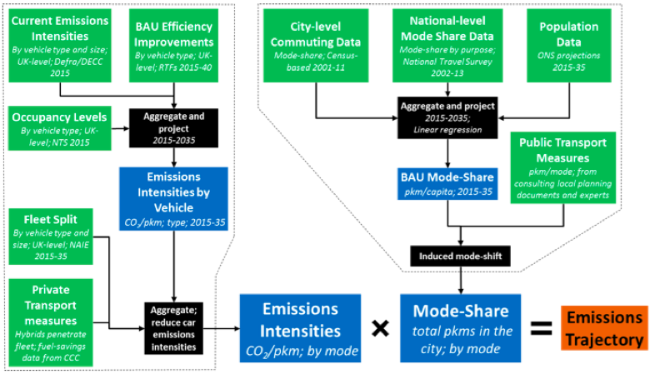

Figure 3: Example methodological process for developing an emissions scenario for the transport sector, drawn a study that employed the same methodological approach (Millward-Hopkins et al 2017)

Further details on the methodology employed in these and other urban bottom-up low carbon investment studies can be found in Gouldson et al (2015).

1. **Case studies**

In the following, contextual information is provided on the urban area considered in each case study, high level results from the economic analysis are summarised, and key areas of potential action raised by the case study are revealed.

* 1. **Kigali, Rwanda**

Kigali is the capital of Rwanda, a country in East Africa with a population of 12.2 million people and the highest density of any non-island African nation. Kigali is home to approximately 10% of the population and is growing rapidly with the population more than doubling over a ten-year period. While the nation as a whole remains among the world’s 20 poorest, economic growth has averaged more than 8% per annum since 2000 and the nation has performed highly on levels of corruption, rule of law, competence of public services and ease of doing business (World Bank 2018a; Ansoms and Rostagno, 2012).

Colenbrander (2018b) finds that rapid urban growth and rising affluence have led to exponential increases in energy use and emissions, with emissions from transport rising 8.9% per year and emissions from the building sector rising 8.1% year and expenditure on energy increasing tenfold since 2000. Looking forward over the next 15 years the city’s total energy consumption is projected to increase by 187.0% while expenditure on energy rises 249.7%. On a per capita basis both expenditure on energy and GHG emissions will remain low – less than one-tenth of the average of developed nations a decade into the future (World Bank 2018b). However, rising use of imported fossil fuels has created the opportunity for low carbon measures to save substantial amounts of money, and low carbon investments have the potential to generate significant wider benefits to the wider population.

Investments for which a financial case and a ‘carbon case’ (a reduction in GHG emissions) are found in opportunities to invest in electric motorbikes, an expanded and rapid bus network, solar hot water heaters on homes and businesses, and in landfill gas capture and utilisation facilities, amongst other areas. Across the city, results of the study find that GHG emissions could be reduced by 39.0% relative to business-as-usual trends through investments that would more than pay for themselves on commercial terms over their lifetimes. Investment of USD 920.7 million across these projects would generate annual average savings USD 173.2 million in fuel, paying back the investment, on averages, in 5.3 years. Options for investments are found across the commercial, residential, transport and waste industries, with particularly impressive opportunities in the waste and transport sectors.

* 1. **Recife, Brazil**

Recife is among the ten largest cities in Brazil with a metropolitan area population approaching 4 million people (UN DESA 2018). An industrial hub of the North East of Brazil, Recife is a centre for processing agricultural goods such as sugar cane and soy beans, a major port, and staging area and connection point for offshore oil platforms. Due to its location and low elevation Recife is one of the most vulnerable cities in Brazil to the impacts of climate change. More than four-fifths of the urban area is within 30m of the coastline and the average elevation of the city is less than 4m above sea level. Under a scenario where sea levels rise only 0.5m-1.0m, it is predicted that near to one-quarter of Recife would be under water (Costa et al., 2010*).

Colenbrander (2017) finds that the transport sector is responsible for almost two-thirds of GHG emissions in Recife (65.6%), followed by waste production (19.3%), household energy use (6.4%), industrial energy use (4.9%), commercial energy use (3.8%) and government energy use (0.4%). Over the period from 2015 to 2030 total energy use in Recife is anticipated to increase by 91%, carbon emissions by 79% and energy expenditure by 174%. While energy use and emissions will both remain significantly below the OECD average, rapid growth will lead to the proportion of GDP spent on energy rising from 8.7% to 12.1% by 2030, leaving a reduced proportion that can be spent by the infrastructure authority, businesses, and households.

A city-wide investment program in low carbon measures is found to hold potential for both reductions in emissions and economic benefits for the economy. Among the measures showing opportunity for financial returns as well as GHG emissions savings, improving air conditioners efficiency, hybrid and alternative fuel buses and bus rapid transit networks, residential solar panels, and expanding a recycling network are among the options found to hold the most potential. Modelling reveals that investing approximately 0.9% of GDP across the economy annually in these and other measures could yield a 24.3% reduction in GHG emissions against the business-as-usual scenario, generate $585 million in annual savings in energy expenditure, and provide a payback (across the investment scenario) of 5.7 years at commercial interest rates.

* 1. **Tianjin, China**

Located in North-Eastern China, Tianjin is one of the 20 largest cities in the world, and will be a part of potentially the world’s largest city when it is amalgamated with Beijing and Hebei to form the Jingjinji Metropolitan Region (UN DESA 2018). A hub for industry and port for goods produced in Beijing and inland cities, Tainjin is also one of four municipalities directly controlled by the central government.

Among Chinese cities Tianjin has been a leader on climate action. Tianjin was one of the original members of the Program for Low-Carbon Pilot Cities and Provinces in 2010, and the Program for Carbon Trading in Pilot Cities and Provinces 2011. In addition, Tianjin adopted one of China’s first mandatory residential energy codes in 1997 and applied a more stringent revised code in 2004 (TMJCC 2004). Since the early 1990s Tianjin has seen accelerating population and economic growth. Between 2000 and 2015 the population grew from to 6.7 million to 15 million inhabitants and by 2030 the city’s population is projected to rise to nearly 20 million (UN DESA 2018).

A program of action across the industrial, transport, commercial, residential and waste sectors is found to show a significant economic case for action against GHG emissions. Gouldson (2017) finds investments that generate financial returns and emissions savings in an number of fuel switching and efficiency measures in different industrial sub-sectors, in raising the fuel efficiency of vehicles, congestions pricing in the central business district, and in applying green building standards to new buildings, among other areas. Across measures, investment of $39 billion in total, or 1% of 2015 urban GDP annually for 10 years, could generate savings in energy use of $8 billion USD, pay back the original investment in 5 years and reduce GHG emissions 18%.

* 1. **Palembang, Indonesia**

Palembang is one of the ten largest cities in Indonesia and the capital of the state of South Sumatra. An important port and also a centre for wood and paper products, rubber and plastics, and light manufacturing of fabricated metals, machinery and other products, Palembang has seen steady population and economic growth of the past two decades (UN DESA 2018).

GHG emissions from Palembang in 2018 are estimated to come primarily from the domestic (42.6%) and industrial sectors (27.4%), with the commercial and public buildings (15.4%), waste (4.0%), and transport sectors (10.7%) generating relatively smaller, but growing volumes of emissions. As a result of the growth of the industrial sector it is estimated that 18.7% of urban GVA was spent on energy each year, a portion that is approximately three times greater than the global urban average (Gouldson 2015). With further industrialisation and modest increased in energy prices this proportion could increase to 20.9% in 2025 based on the trends identified in Colenbrander (2016).

Large opportunities in the city for generating emissions savings and economic returns (at the urban level) are found across the buildings, transport, waste and industry sectors in Palembang. Landfill gas utilisation and energy from waste facilities are found to have the potential to save more than 3Mt of CO2 emissions over their lifetimes (approximately half of one year’s total emissions from the city) while generating financial returns for the local government through gate fees and the sale of electricity. Additionally, developing a bus rapid transit network, energy efficiency and fuel switching measures in the industry sector and the implementation of energy efficiency standards for air conditioners are highlighted as opportunities for action. Collectively, investment of $405.6 million over 15 years is found to have the potential to reduce energy bills by $436.8 million, generate a payback of less than one year while reducing GHG emissions 24.1%.

1. **Reassessing the role of urban government**

The urban context varies considerably across the case studies presented. While Tianjin is a megacity with more than 10 million inhabitants, Kigali has a population of fewer than 2 million. Palembang and Recife are on the equator and in countries with parliamentary systems while Tainjin faces harsh winters and is in a country with a one-party system. And while Palembang and Tainjin have heavy industry at the core of their economies and are connected to carbon intensive electricity grids, the economies of Recife and Kigali have relatively larger service sectors and are connect to electricity grids that are lower carbon. Despite these differences, common findings around the technical and economic case for climate action emerge.

Firstly, a significant economic case for action is found in each urban area using market interest rates and existing energy prices and capital costs. In each case between 14% and 24% of GHG emissions could be reduced against a baseline scenario over the coming decade by implementing actions that provide financial returns and that are currently available for investors. The existence of these opportunities raises questions around the extent that a financial case is currently limiting action in these contexts, or whether a wider set of market failures, involving financial and non-financial aspects of these investments, may be the critical area for policymaking.

Secondly, while the total amount of investment required in each urban area amounts to billions of dollars (USD), the majority of investment comes in the form of a very large set of relatively small investments. Across the urban areas more than 60% of total GHG mitigation comes from actions that individually cost less than $10000 USD. In Kigali electric motorbikes show a strong economic and financial case, in Recife high efficiency air conditioners can generate substantial economic savings even after accounting for their higher upfront cost, and in Palembang green building standards show a strong economic and environmental case. The scale of these investments is too small for international investors or national investment portfolios, but in cases too large for individual households, suggesting a possible need for public policy and a possible shortcoming of climate policy analysis focused only on multi-million dollar projects.

Finally, the case for action in each city rests both on technically complex actions developed from new technologies and at times requiring high levels of technical capacities, and on a large set of well-established and, at times, relatively prosaic, actions. New technologies around heating and cooling systems, traffic management and industrial processes are complemented by actions to improve building insulation, encourage biking and walking, and increase maintenance to boilers and other energy systems in homes and factories. Raising levels of low carbon finance in urban areas may therefore require as much consideration of technologies and practices that are long established as on new and innovative investments.

What role, if any, exists for urban policymakers given these findings? An inter-related set of challenges stand in the way of public and private low carbon actions. Financial variables including interest rates, energy prices and capital costs can serve as barriers by limiting the scale of finance available finance while non-financial factors, include the availability of a workforce with necessary skills, access to knowledge and supply networks, legal frameworks, government policies and environmental factors can also affect the scale and pace of low carbon action.

Reviewing recent literature that has explored the evolving role of urban governments (***) and the case studies presented, we identify six place for urban policymakers to support action on climate change.

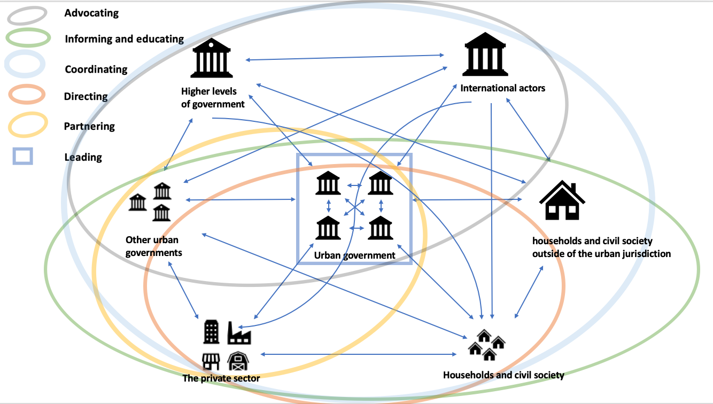

Figure 4: Categorisations of places for urban policymaking around climate action

*Leading – Investments that support wider ecosystems of actions, set an example of the government’s vision for the future, and lay groundwork for future investments*

Major investments, in transport, buildings, the energy network, and other aspects of urban infrastructure, have long-lasting consequences for energy use and emissions. While a car or air conditioner purchased today is unlikely to still be in use 20 years in the future, buildings are expected to last 40 years, if not substantially longer, and roads and utility networks can last longer still. Investments in some kinds of infrastructure thereby influence how we live and work in urban areas far into the future, potentially ‘locking-in’ emissions and energy use ().

The most expensive of these investments are rarely lead by municipal governments alone, in developed or developing urban areas. Smaller investments, however, can help to shift patterns of energy use and emissions in a similar way, while signalling an urban area’s commitment to a longer-term program of action. Cycle lanes emerge in each study as an investment with a relatively low cost and a modest, but not insignificant, impact on GHG emissions. In Kigali, for example, an ambitious program to expand cycle lanes have the potential to reduce emissions equivalent to removing more than 1000 vehicles off the road each year and levels of citywide energy expenditure savings that could cover the cost of the investment over a five-year period. In addition to these benefits, the monetized value of improved public health from studies in similar contexts is found to be larger the value of energy savings (Gouldson et al 2018). The value of both energy savings and health benefits, however, are expected to be all but impossible for the municipality to directly capture, meaning that the investment should not be anticipated to generate any financial returns.

Beyond the impact of cycle lanes on energy use and emissions, such investments can help to establish and legitimize an alternative to single occupancy vehicles as a primary mode of transport, and in so doing, lay the ground work for a wide range of investments than can further reduce GHG emissions. Moderate and higher levels of density in residential and commercial buildings, for example, are more feasible when the transport capacity of road networks is increased by cycle lanes and other non-motorised options (). Similarly, by reducing the time it takes residents to reach their local station, cycle lanes can increase the coverage, and therefore the feasibility, of public transport options ().

The barrier to greater implementation of cycle lanes, as well as similar ‘leading’ investments, is in part the financial challenge of finding funding for implementation. To a greater degree, however, implementation may struggle against the political and social challenges of highlighting to the public the long-term and non-monetary benefits of a shift towards a non-motorised transport network (Handy, Van Wee & Kroesen, 2014).

*Partnering – Working with national and international actors, including the private sector, to realise investments that would otherwise be beyond the capacity of the local government and that could not be expected to be implemented by the private sector alone*

In addition to having long-term impacts on energy use and emissions, public infrastructure, from transport networks to waste facilities, schools and libraries generate substantial benefits for urban populations and businesses. Indeed, the existence of these kinds of ‘public goods’ is fundamental to the social and economic value of urban agglomerations (Tsai 2017; Chatman & Noland 2011). These benefits, however, also tend to be diffuse, non-monetary and long-term and are consequently often excluded from traditional cost-benefit analysis’ and hard to rationalise from the perspective of the private investor.

Projects with these attributes are found throughout the cases studies described. In Kigali, a bus rapid transit system could improve access to jobs and services for populations across the city and support further investments in the transport system. In Palembang a waste-to-energy facility could create new employment opportunities and help to support a more effective waste collection system, leading to a cleaner and healthier city. In Tianjin an expanded subway network could contribute to reducing congestion and improved air quality, helping to create a more liveable city and supporting liveable density.

In wealthy urban contexts an integrated and long-term approach to urban planning can allow governments to capture increases in value around projects in order to provide finance. Development charges, housing and business taxes, regional sales taxes and municipal bonds, often deployed in conjunction, are some of the conventional approaches to raising finance (Junghans and Dorsch, 2016). In developing contexts, however, where formal tax registries may be incomplete and resource shortfalls can make it challenging for investors – both public and private - to embrace long-term benefits, self-financing of large projects is unrealistic. Indeed, even in the world’s wealthiest cities large infrastructure investments are frequently supported by higher levels of government. Adding to the challenge, larger projects can be technically complex, a complication that contributes to project delays and cost overruns in a majority of major government led infrastructure projects worldwide (Flyvbyerg et al 2015).

In these contexts, technical and financial support can be found by partnering with private and public actors. Development assistance for low carbon action has historically directly a relatively small portion of low carbon assistance to urban areas, both in absolute terms (Barnard 2016), and with reference to the scale of low carbon opportunities in urban areas (Sudmant et al 2017). Recently, however, global climate funds have turned their attention towards cities and the transport sector, with both the Global Environmental Facility and the Green Climate Fund introducing an urban focus to their latest investment programs. Alternatively, public private partnerships (PPPs) connect an individual company or a consortium with the government, helping to provide investment and technical capacity, and to distribute risk among a wider number of actors (Glemarec and Connelly, 2011).

Developing a financial case and equitably allocating risk are core challenges for realising investment in projects with public good characteristics. At the same time, successful implementation of public-private projects depends on political support, community and public support, transparent procurement policies, and established governance procedures that can allow project challenges to be dealt with quickly and effectively (Osei-Kyei & Chan 2015). Non-financial challenges emerging from the divergent interests of project partners and the design of contracts and governance procedures are therefore critically important for the successful implementation of PPP projects (Wettenhall 2003; Zhang 2005).

*Directing – Actions that apply the unique powers and position of urban policymakers to influence the path of future emissions*

With exceptions, few urban policymakers have direct authority over the most visible policies and programs that affect the growth and development of urban areas. Tax policies, trade agreements, immigration and emigration laws, funding for schools and hospitals, and many other critical services, laws and policies are infrequently devolved to urban governments. In specific areas, however, urban government policies have critical influence.

This is particularly the case around urban form. Whether directly, by approving or rejecting developer’s plans, or indirectly, through the design and development of supporting infrastructure such as roads and utilities, urban governments can have significant influence over how urban areas grow and develop. In the short term, emissions from building new infrastructure account for more than half of the total footprint of emissions from many cities in China (Shan et al 2016). Of greater significance, the way urban areas are designed, and the extent that they are ‘designed’ rather than organically developing, influences emissions and energy use far into the future (Floater et al 2014; Ahlfedlt and Pietrostefani 2017).

Large scale changes in the design of urban areas were not investigated in these case studies, but a large number of smaller actions that could have long term impacts on the urban landscape were considered. Green building standards in Palembang were found to have potential to generate economic benefits and GHG savings for decades into the future while in Recife, Tianjin and Kigali, actions to extend public transport networks were found to have the potential to reduce personal vehicle use and urban sprawl, leading to more compact and connected urban areas.

The challenge for urban policymakers lies in being able to assess the consequences of individual plans and developments against a longer-term vision of their urban area - often in the absence of credible and comprehensive information. Growth and change in urban areas, rather than happening between static blocks and areas under planning (as envisioned by the makers of ‘SimCity’), is a dynamic and organic process in which any single planning application or ordinance code can seem inconsequential. And the barriers to more compact, coordinate and connected development can be financial, in the form of the higher cost of public and multimodal transport networks, but also political, in the form of established interest groups such a house builders, and social/behavioural, in the large numbers of citizens who may oppose increases in density or shifting to non-motorised transport options. City networks, such as ICLEI and C40, and open-source planning tools, such as the World Bank’s CURB tool, are currently playing an important role in this context, helping urban policymakers develop long-term plans supported by evidence and the examples provided by other urban areas.

*Informing and educating – Actions that improve the functioning of existing institutions and governance arrangements, and that raise awareness among business and the general public of opportunities for action*

Failure to implement low carbon actions that generate economic returns can result from the challenge of turning economic opportunities into financial business cases, legal conflicts, and political conflict, to note only a few examples from the previous sections. In other cases, households and businesses are simply not aware of opportunities available to them, or able to realise them due to lack of skills or knowledge.

Opportunities for information and education to influence emissions and energy use are found in each of the four case studies. In Recife turning down or automating thermostats is among the most cost-effective measures for reducing emissions (in large because it comes with zero cost). And in Tianjin and Palembang the application of maintenance procedures in the industry sector are found to pay back over months, rather than years. In each of these cases actions by any individual yields only a small impact on citywide energy use and emissions. Actions across companies and neighbourhoods, however, generate very substantial financial and GHG benefits.

In their position working with businesses, members of civil society and other urban governments, urban policymakers are in a unique position to support the provision of information. While a majority of literature on energy efficiency initiatives led by informational campaigns have been based on developed world contexts (Gillingham, Keyes & Palmer 2018), an increasing number of papers identify successful campaigns in developing contexts (c.f Gyamfi et al 2017).

Local governments can also engage in supporting skills and training in order to ensure the local workforce has the knowledge needed design, install, operate and maintain low-carbon measures. The Private Sector Federation of Rwanda, an industry group, has formed a partnership with government to explore opportunities around low carbon action while training small and medium-sized businesses in entrepreneurship, planning, and accounting (PSF, 2016). Similar programs on other parts of sub-Saharan Africa and least developed countries have had significant impact at relatively low cost (Mano et al., 2012).

The financial cost of these programs can be significant, especially for developing municipalities with limited resources. The barriers to action these programs help to challenge, on the other hand, around asymmetries of information between households and energy providers, the limited capacity for individuals to engage in ‘optimizing’ behavior, and principal-agent problems, are often non-financial.

*Coordinating – Actions facilitated by urban policymakers bringing together key actors*

Effective coordination and communication, both horizontally across government agencies and private actors, and vertically between local actors and national institutions, is critical for developing large investment projects. In the case study from Rwanda, for example, action to raise the integration of renewables in the electricity grid would require the coordinated action of at least three national government agencies (The Ministry of Infrastructure, Ministry of the Environment, and the Ministry of Finance and Economic Planning), private developers, international sources of finance, and local governments.

In Palembang, a high degree of regulatory independence allows the city to develop major transport projects without explicit support of regional or national actors. Nonetheless, major investments in bus rapid transit and light rail in recent years have progressed only with the support of the national finance and transport ministries, guidance from the regional government, agreement of neighbouring municipalities, and cooperation of multiple municipal authorities.

Even where investments are relatively smaller, local governments can play an important role coordinating actors and building cooperation towards increasing low carbon investment. In Brazil, local authorities have substantial autonomy designing and implementing local development strategies but lack authority over important areas, including building standards and industrial efficiency. In their connections with other municipalities and levels of government, and the information local governments have about businesses and developments in their urban areas, members of local government are in a unique position to connect businesses with Energy Service Companies (ESCOs) who can provide finance and expertise around low carbon investments.

In each of these cases urban policymakers’ unique knowledge of their context – including the needs and interests of their constituents – helps them to bring together key actors. At the same time, urban policymakers knowledge of sometimes labyrinthine political and bureaucratic networks existing within local governments, and between local governments and other layers of government position them to enable interactions that otherwise would be unlikely to happen organically.

*Advocating – Actions from local governments that leverage their position between local actors and national governments to improve institutional practices, increase municipal powers, direct action, or simply provide awareness of an opportunity*

In their position between local actors and higher levels of government, urban policymakers are in a unique position to raise the profile of local issues. The case study on Tianjin, China, presents a unique perspective on this role of urban policymakers. As one of only four municipalities controlled by the central government, policymakers in Tainjin have been able to advocate for ambitious climate, energy and environmental policies and the city was adopted one of the first Chinese residential energy codes in 1997. Results from the 1997 codes have led to more strict regulations in 2004 and 2007, and informed policies that now apply widely to urban areas in China (Oshita et al 2015).

A second example comes from the Kigali case study. Analysis in Sudmant (2017) and Colenbrander (2018) find that shifting from conventional to electric motorbikes would not only improve air quality and reduce carbon emissions, it would also generate economic benefits. While an electric bike and reserve battery are approximately the same price as a conventional moto, the costs of operation are radically different: A typical ‘moto’ driver could save $2-3 USD per day in fuel costs by shifting to an electric bike, an amount approximately equal to their daily wages.

Uptake of electric motorbikes, however, has remained low. Delays at customs are said to require as many days as shipping electric motorbikes from China to the boarder (approximately 40 days) due to a lack of clarity around how electric motorbikes should be taxed. In addition, licencing requirements for electric motorbike owners are uncertain and require coordination between the Rwanda Revenue Authority and the Rwanda National Police (which are responsible for licensing of vehicles). To address these challenges policymakers in Kigali can advocate for expedited customs procedures, clarifications around legal frameworks, and better trained boarder officials.

Many issues local governments need to advocate for are regionally and locally specific. Common across many developing countries cities, however, is a limited ability to raise finance through financial instruments such a municipal bonds. Across developing nations less than one-in-five cities have access to the bond market (ref). Programs such as the World Bank/C40 Cities Climate Leadership Group City Creditworthiness Initiative are helping address this problem by helping urban areas develop the legal, regulatory, institutional, and policy frameworks for sub-national borrowing.

**5. Implications for urban low carbon action**

While urban areas are newly considered in the more recent IPCC processes and in the Sustainable Development Goals, the wider ‘urban agenda’, and therein the specific roles and place for urban policymakers in climate action and other global challenges, is still be in the process of emerging (Parnell 2016; ref; ref).

Grounded in their share of population, GDP, energy use and other metrics that demonstrate their contribution to climate change, a growing number of commitments from urban areas reflect an understanding that cities have substantial responsibility to address GHG emissions. In the last 5 years more than 8000 urban areas covering 15% of the global population have made emissions reduction commitments, frequently ones that are more ambitious than those set by the nations they reside in. Supporting this perspective, a growing body of academic and NGO literature have started to develop consumption accounts that in many cases substantially increase the footprint of urban areas by including upstream emissions (C40, Millward-Hopkins et al 2018; ref; ref). Moran 2018, for example, suggests that the world’s 50 largest cities…(Moran 2018).

At the same time, a growing literature on urban climate action has been developing our understanding of urban government’s relevance to addressing urban GHG emissions. In these analysis’ pioneering urban governments’ political dynamism, ability to infuse action with local motivations and capacity to experiment and develop new practices and approaches are emphasised (ref ref ref ). Networks between cities promote knowledge exchange, capacity support and encourage experimentation and leadership (Kern and Bulkeley 2009), providing means for horizontal governance between urban areas and vertical coordination with national and international actors. In these ways polycentric governance approaches at the local and urban levels are seen to address and overcome ‘governance gaps’ (Abbott 2014) and lead to opportunities for local policy to guide and deepen international programs of action (Hale and Roger 2014).

Analysis here adds to this literature by developing a structure for the roles of urban policymakers, and by suggesting that urban governments are at the metaphorical centre of an urban governance landscape that is based discretely in an urban area, but that also extends horizontally to other urban spaces, and vertically to regional and national actors. Urban governments in this context have a critical role helping to establish the conditions for action in urban areas with their largest impact potentially in helping to address non-financial barriers to action.

Financial barriers, and specifically the returns on low carbon investment, have historically been at the centre of discussions around low carbon action. This can be seen in the major mechanisms of climate finance, including the Clean Development Mechanism, Joint Implementation (JI), and International Emissions Trading (IET), designed under the Kyoto Protocol, and the EU Emissions Trading Scheme, all of which were developed with a focus on increasing returns for low carbon investments. This can also be seen in the continued consensus amongst economists that carbon pricing is fundamentally “indispensable” for addressing climate change (1: Stiglitz et al 2017; Tol et al 2018) and in key global institutions focus on carbon pricing and fossil fuel subsidies as critical barriers to low carbon action (OECD 2018b; IMF 2018*; IEA 2017*, NCE*; ODI*). To the extent that non-financial barriers are considered by investment frameworks, in for example, the *Climate Investment Readiness Index* (World Bank)*, Readiness for Investment in Sustainable Energy* (World Bank*)*, *Strategies to Scale-Up US Renewable Energy Investment* (ACORE) and *Catalyzing Climate Finance* (UNDP), a focus has been placed on regional and national policymakers over urban and other non-state actors.

Here, the very existence of an unrealised financial case for action in each case study raises questions around the extent of non-financial barriers and whether they are receiving enough attention. In addition, the important role urban governments can play addressing non-financial barriers is illustrated in the categorisation of places for urban policymaking (figure 4) and in the examples from the case studies.

At the same time as underlining urban policymaker’s broad relevance to urban climate action, aspects of this analysis also align with a more limited perspective on the ability of urban policymakers to lead climate action (c.f Bulkeley et al 2014; Hale and Riogers 2014; Hickman 2016; Hickman 2017; Schreurs 2008). Insofar as urban areas are widely relevant to action, they are seen to typically play an intermediary and indirect role, and to depend on a wider ecosystem of actors taking on responsibilities.

In contrast with national actors or local actors, such as businesses and households, urban policymakers have few opportunities to unilaterally and directly affect emissions relative to the scale of their carbon footprint. National governments, for example, typically have vastly more power over ‘technical’ inventions such as tax policies or investment programs while behavioural interventions and lifestyle change are more likely to be implemented by households (). In many cases ‘critical agency’ continues to lie outside of urban spaces. Across a range of levers, especially those related to industrial practices, energy efficiency, tax policy, product standards and trade, while urban governments have a degree of influence, regional and national governments continue to have key powers (SEI; Barrett?).

Beyond legal and institutional design, urban government’s intermediate and indirect role in climate action also reflects the fundamental nature of urban spaces: as open systems, urban economies are at the end of some supply chains, the beginning of others and somewhere in-between for countless more, leading to few cases where the set of actors and activities related to a set of emissions are discretely within their geographic (and legal) boundaries. While a majority of global energy use and emissions pass through, or take place, in urban areas, a tiny fraction are produced by urban governments or ‘consumed’ in the goods and services they provide their citizens.

These considerations suggest a need for caution as an increasing number of urban areas make bold commitments to action. Commitments from urban areas to radically reduce emissions made without support from regional and national governments will not only be challenging to achieve, but may inadvertently shift responsibility away from actors whose unique powers are critical for action. Moreover, by establishing aggressive targets based on local accounts (territorial, consumption or combinations of these), urban governments may focus on the specific places where they have agency within their own jurisdictions, at the cost of actions that may have a larger, though longer term and more dispersed, impact. Evidence for this may be seen in urban governments placing commitments to shift to low carbon vehicle fleets and to support energy efficiency in their own buildings at the centre of their climate action plans, efforts whose impact on the overall emissions of an urban area are frequently inconsequential in the context of their targets or the footprint of their cities (CCCAP paper?).

The relative focus between barriers to action (financial versus non-financial) and between types of action (direct action versus indirect action) have significant consequences. Alternative policy approaches compete, not only for financial resources and technical capacities, but public acceptance and space on the political agenda (Weible and Jenkins-Smith 2016; Howlett et al. 2016; Sabatier 1988). In a contested political environment – as is frequently the case around both urban and climate change issues – the opportunity for comprehensive policy approaches can be limited, and the incentive for narrowly defined policies to be framed as ‘solutions’, such carbon taxes or the conversion of a municipal bus fleet, can be high. As a consequence, urban areas may find themselves taking approaches that that leads to only ‘mild’ decarbonisation (Gouldson 2015), and to missed opportunities for low and negative net cost options (Sudmant 2016). Or more concerning, focus on the wrong approaches may lead to actions that lead to structural and institutional carbon lock-in (Grubb 2014). In other words, a focus on the wrong approaches by urban governments may prevent us from addressing the deeper structural issues tying our economies and societies to fossil fuels.

**Conclusion**

As climate action is increasingly decentralised - progressing from local initiatives and bottom-up processes – and action is increasingly led by new and innovative form of governance, urban policymaker’s relevance to climate action may only be increasingly. Assuming that urban area’s relevance to climate action should translate into responsibility for action, however, may prevent urban governments from maximising their impact. Rather than leading action, urban areas